ZD,
REPORT OF JOINT INVESTIGATION VISIT BY NOSDRA, DPR, SPDC, RIVERS STATE MINISTRY OF ENVIRONMENT AND BODO WEST COMMUNITY REPRESENTATIVES AT 28” BOMU – BONNY TRANS NIGER PIPE LINE (TNP) RIGHT OF WAY @ BODO WEST IN GOKANA L.G.A OF RIVERS STATE.
INTRODUCTION
Acting on your directives on the SPDC request latter sent in on 14th September 2015, a Joint Investigation Visit (JIV) was conducted at the 28’’ Bomu – Bonny Trans Niger Pipeline (TNP) Right of Way at Bodo West in Gokana L.G.A of Rivers State on the 13th of September, 2015 at about 12:50Hrs. The investigation was completed successfully on the same day. This report provides details.
INCIDENT PARTICULARS: 2015_ 1483495
FACILITY AFFECTED: 28’’ BOMU-BONNY TNP ROW @ BODO WEST IN RIVERS
STATE
DATE OF SPILL: 10/09/2015
DATE OF INSPECTION: 13/09/2015
CAUSE OF SPILL: SABOTAGE (See Fig.1a & b)
QUANTITY OF CRUDE OIL SPILLED: 6.25bbls (Approximately 7.0bbls)
SPILL POINT COORDINATES: NOTHINGS: 4.58362 (Latitude)
EASTHINGS: 7.25604 (Longitude)
NATURE OF IMPACT: Area Saturated with Crude Oil
INVESTIGATION TEAM:
- Koms Abam NOSDRA
- Chira Nwuzor SPDC
- Okerinde Solomon SPDC
- Opara R. N. DPR
- Charles Odum RIVERS STATE MINISTRY OF ENVIRONMENT
- Dennis Kaakpo BODO WEST COMMUNITY
- Baba Eigege POLICE
OBSERVATIONS:
- Unknown persons installed a 4’’ Nipple with a Ball Valve on the 28’’ Pipeline at 12 O’clock position, for Crude Oil theft. (See Fig. 1a & b)
- The impacted Area is a Tidal Environment with 1⁰ Mud Flats along ROW (See Fig. 2a & b)
- The whole terrain, made up of Alluvial Deposits (mostly Silty and Sandy Clay in texture, with decomposed Plant Roots) has been saturated with Crude Oil. Pool of Free Phase Oil was observed around the Spill Point and since investigation was carried out at Low Tides, most of the Crude Oil must have been carried away by water and infiltration must have also occurred considering the nature of the Topography. (See Fig. 2a & b)
IMPACTED AREA COORDINATES: 1. NOTHINGS: 4.58367 2. NOTHINGS: 4.58362
EASTHINGS: 7.25610 EASTHINGS: 7.25610
3. NOTHINGS: 4.58359 4. NOTHINGS: 4.58361
EASTHINGS: 7.25606 EASTHINGS: 7.25603
5. NOTHINGS: 4.58369 6. NOTHINGS: 4.58369
EASTHINGS: 7.25606 EASTHINGS: 7.25603

- The Vegetation around the impacted Area showed a wide span of harvested White Mangrove (See Fig. 3a & b)
RECOMMENDATIONS
- Surveillance of facilities need to be intensified to prevent future re-occurrence
- The affected area should be completely repaired and immediately cleaned up.
CONCLUSION
The JIV was successful. This report is subject to your steer and further directives.

Koms Abam
SES

_____________________________
14th September, 2015

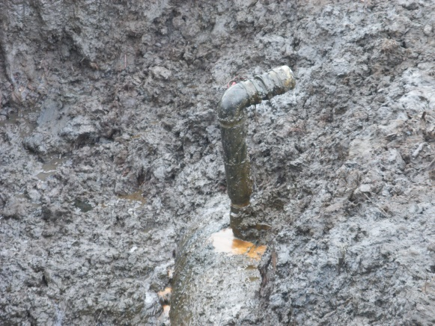 ` 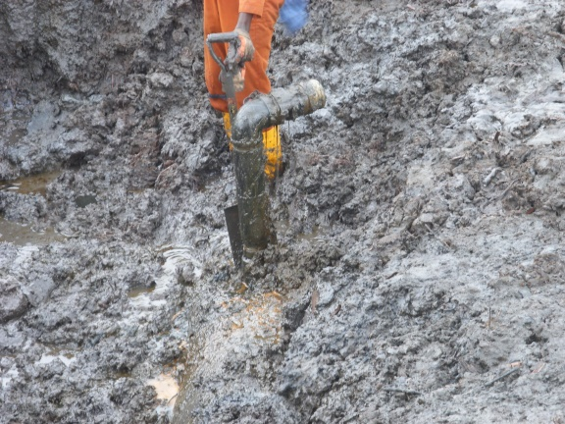
Fig. 1a 4’’ Nipple & Valve installed Fig.1b Installed @ 12 O’clock with an Elbow

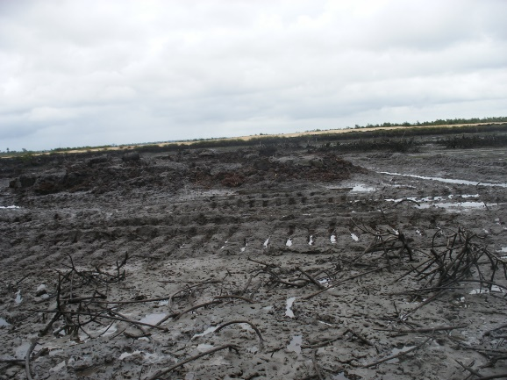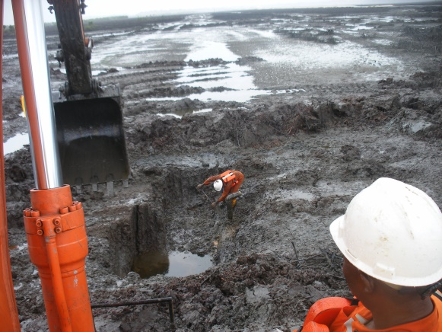
Fig. 2a ROW with 1⁰ Mud Flats Fig. 2b Alluvial Deposits
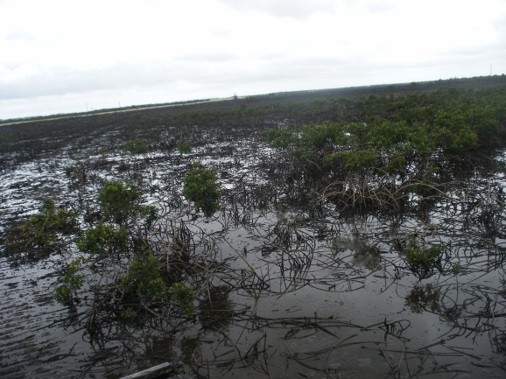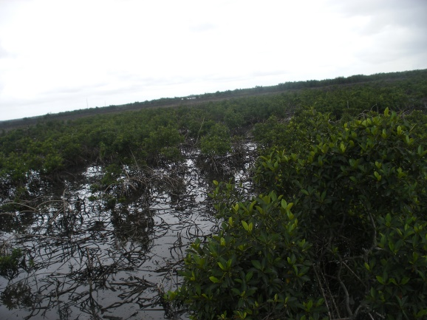
Fig. 3a Vegetation around the Spill Area Fig. 3b Harvested White Mangrove

